Git Hub Repo for Group 23

<https://github.com/pjounimet2006/Assignment2>

Screenshots:

Main Menu:

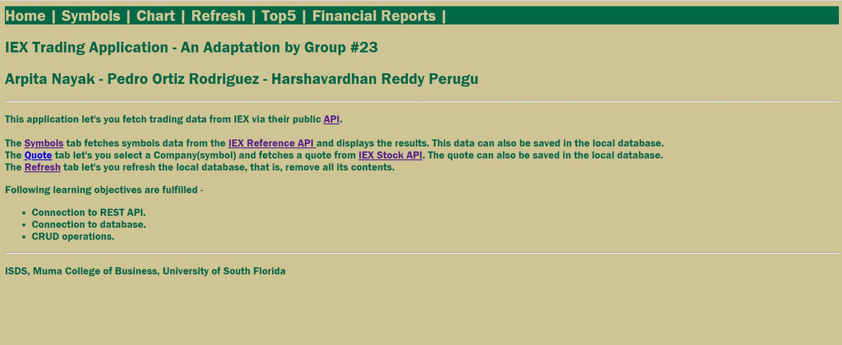

Upgrades Database:

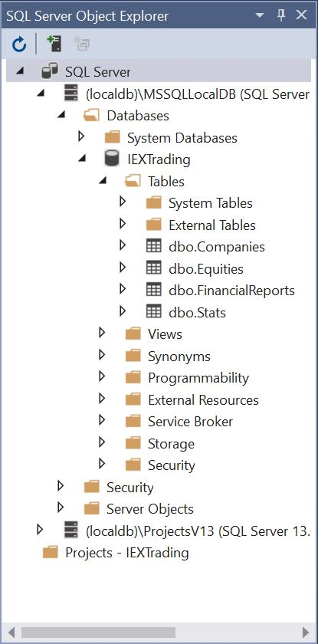

Updated Refresh Functionality Including New Tables:

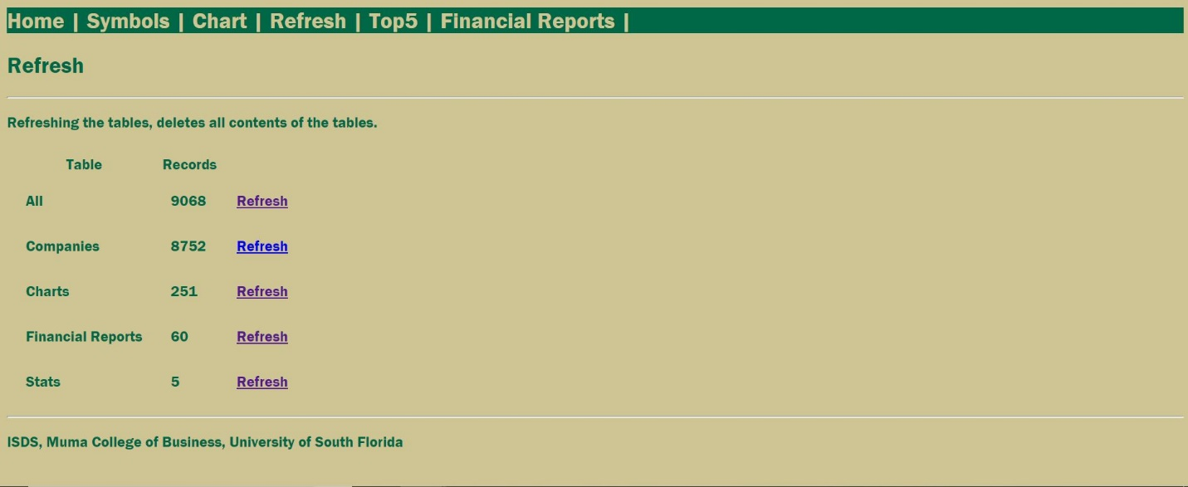

Top 5 Stock Screen according to Current Ratio (Total Assets/Total Debt)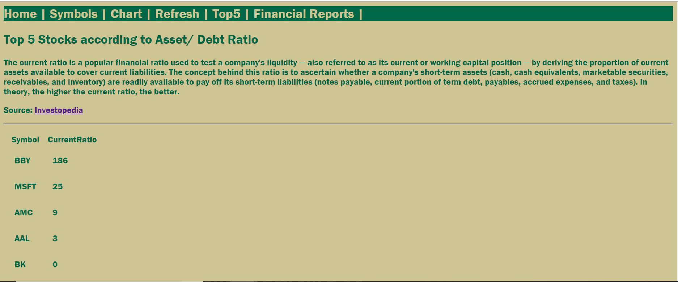

**Team Reflection:**

This Assignment served as great introductory hands on experience handling with MVC developed applications. The initial scripts used through this assignment was the one provided in both class and canvas as an starting point for the assignment. In it we managed to give a simple Top 5 stock ranking based on financial information obtained trough IEX Financial API. As recommended by TA, data was received from IEX using the getFinancials functionality. While this method provides a wide range of information for a given Stock, we found it impossible to get all information on all the 8752 companies available on the IEX platform at the time. For this, we implemented the following actions:

* Created New tables in IEXTrading database (Stats and FinancialReports).
* Changes were made to the _Layout file to include new general site structure.
* New Models Stat and FinancialReport were implemented.
* Views Stats and FinancialReports where implemented
* The following Methods where implemented in the HomeController:
  + public IActionResult FinancialReports(string symbol): Gets view that lets users copy FinancialReports Data from IEX to DB for processing of Ranking.
  + public IActionResult Stats() : Gets view that lets users view Top 5 raking based on FinancialReports chosen by user stored in DB. The method for sorting the symbols was using the Current Ratio (which is the division of Total Assets / Total Debts) from the information available in the FinancialReports. Other possibilities are possible with the vast amount of information available in the FinancialReports, but for the purpose of this assignment this was the only one implemented. The stocks where ranked in descending order and the one with highest Current Ratio was at the top of the Top 5. Since we got error from invoking constantly API methods from the IEX website with the intention of getting FinancialReports, we stored the data in the FinancialReports table and always got the data from